Use this reference to add or drop a course.

INSTRUCTIONS

- Log into Workday and enter the Academics app.

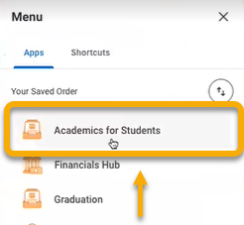

- Click the “Registration” tab.

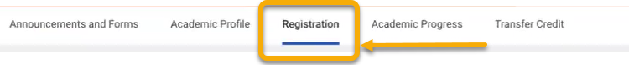

- In the right-hand menu, click “View My Courses”.

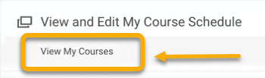

- The courses for which you are currently enrolled are in the My Enrolled Courses table.

The courses that you have already dropped or withdrawn are beneath this table under My Dropped/Withdrawn Courses.

To drop or withdraw from a course for which you are currently enrolled, locate the horizontal scroll bar in the My Enrolled Courses table. Scroll all the way to the right.

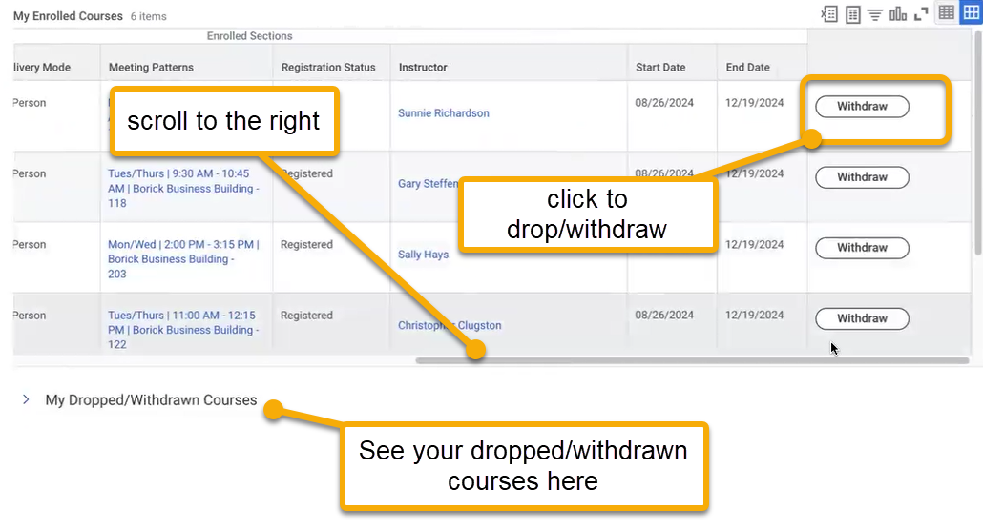

- Locate the course you wish to drop and click “Withdraw”.

- The Withdraw Student Course Registration page will appear. Check “Confirm Withdraw from Course”.

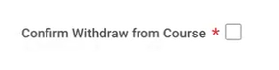

- You may receive an alert to ensure you wish to drop/withdraw from the course.

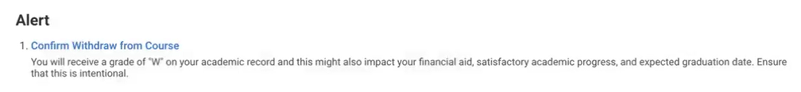

- To proceed, click “OK”.

- (optional) To confirm the dropped course, click My Dropped/Withdrawn Courses under the My Enrolled Courses table.

